- Enter the TFS admin URL: http://si0vm1361.de.bosch.com:8080/tfs/_admin. Select TFS01/Dev.SCRUM from the treeview on the left side and Click on Create a new team
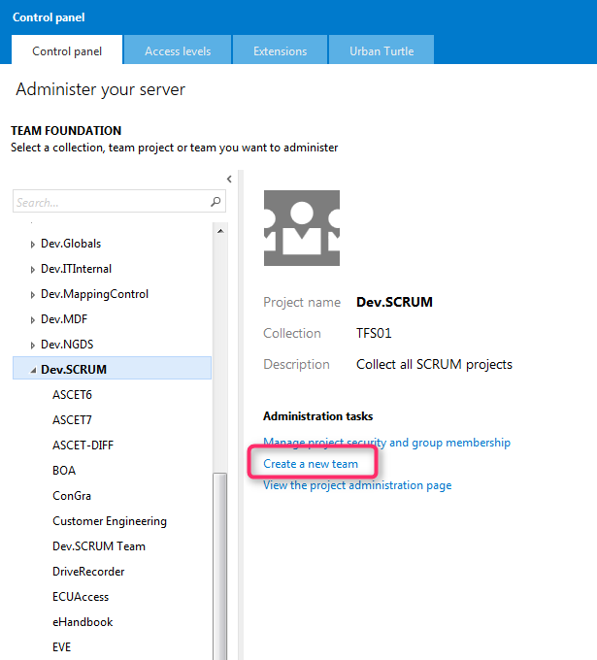
- Fill out the profile data. Make sure the checkbox at the bottom is unselected, as the areapath for the already exists
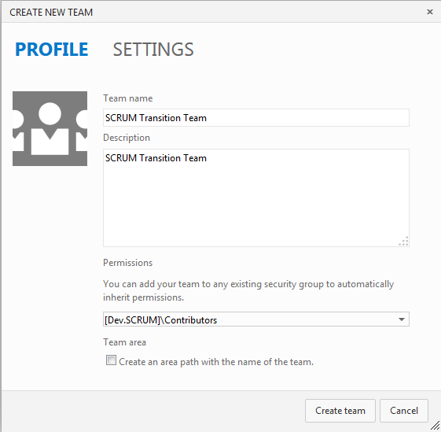
- Select he created team and click on the link for the team administration site
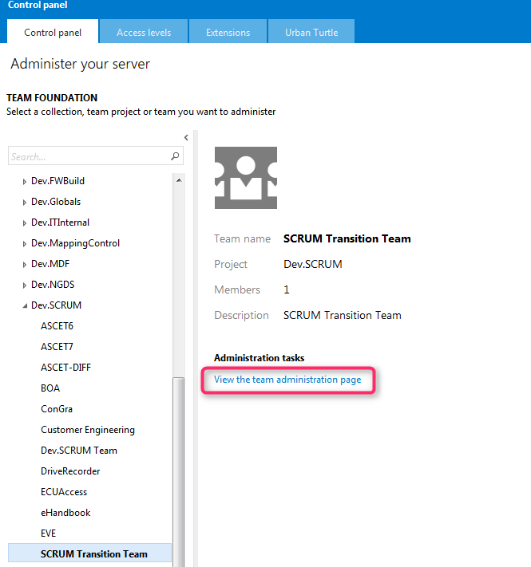
- You will see the below screenshot after clicking on “View the team administration page”
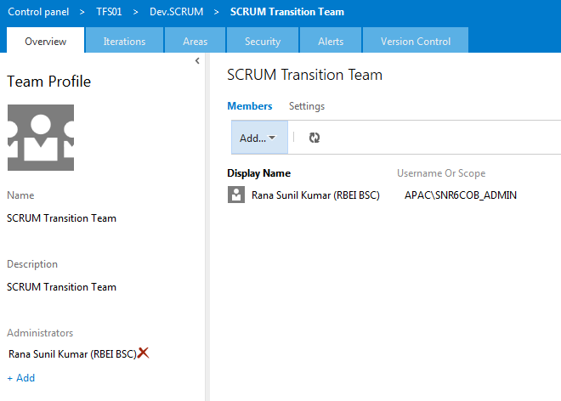
- Click on Add TFS Group option as part of Add Button to add the already added TFS Groups.
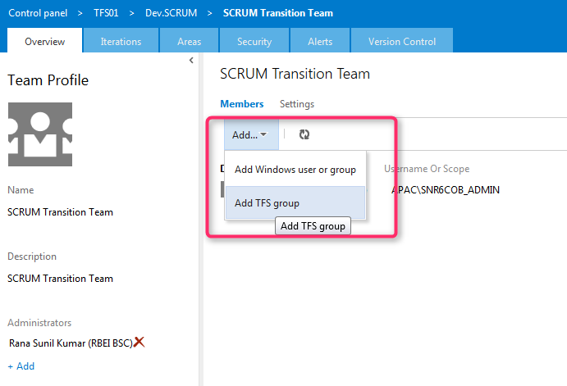
- You will see a Add a Team Foundation Server Group box as shown below. Click on Browse to find and select the already existing TFS Groups. Add the above and corresponding TFS Scrum Groups i.e. TeamName Admins, TeamName Developers, TeamName Readers. Click on Add. 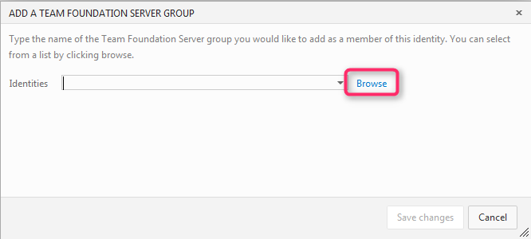

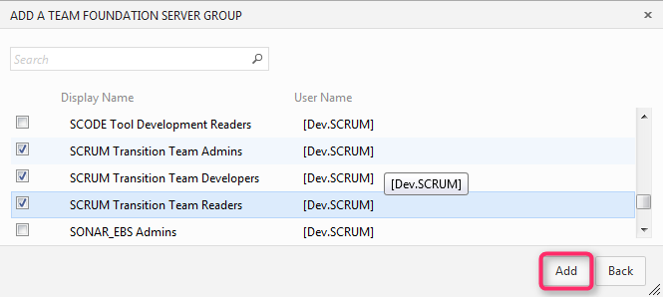
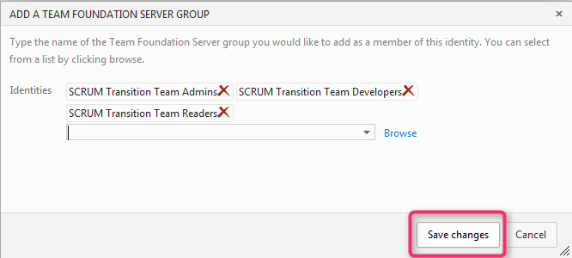
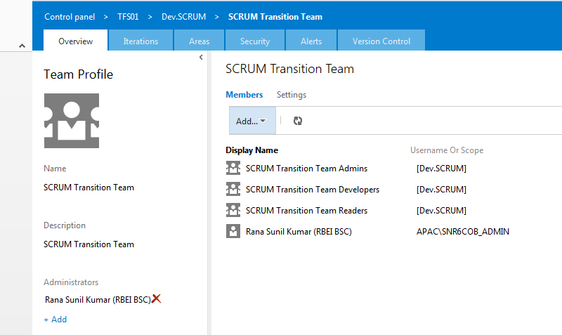
- Click on Iterations Tab and Areas Tab to add the Iteration for this team. You can refer to GLOBAL.SETTINGS file from previous PROD to set the values.
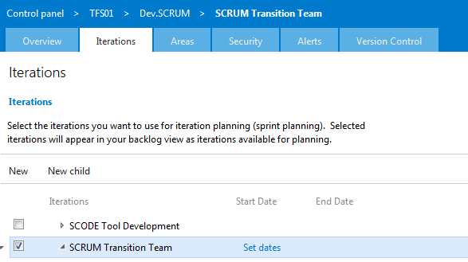
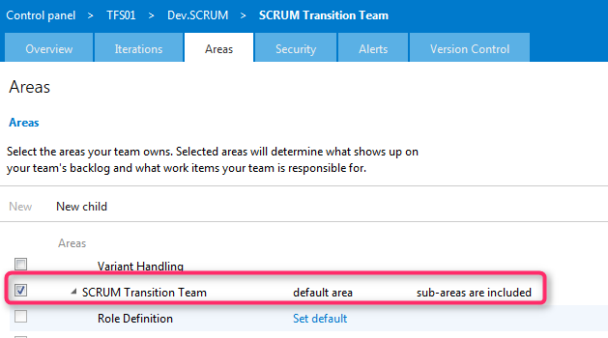
- And set/verify the permissions (if needed) for the team members in the area
(I’m actually not sure if this has to be done, as the areas themselves are already configured.
Just checked it, this step is not necessary.)
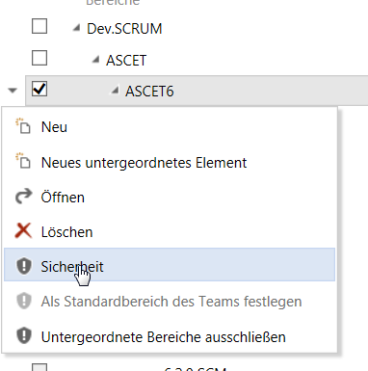
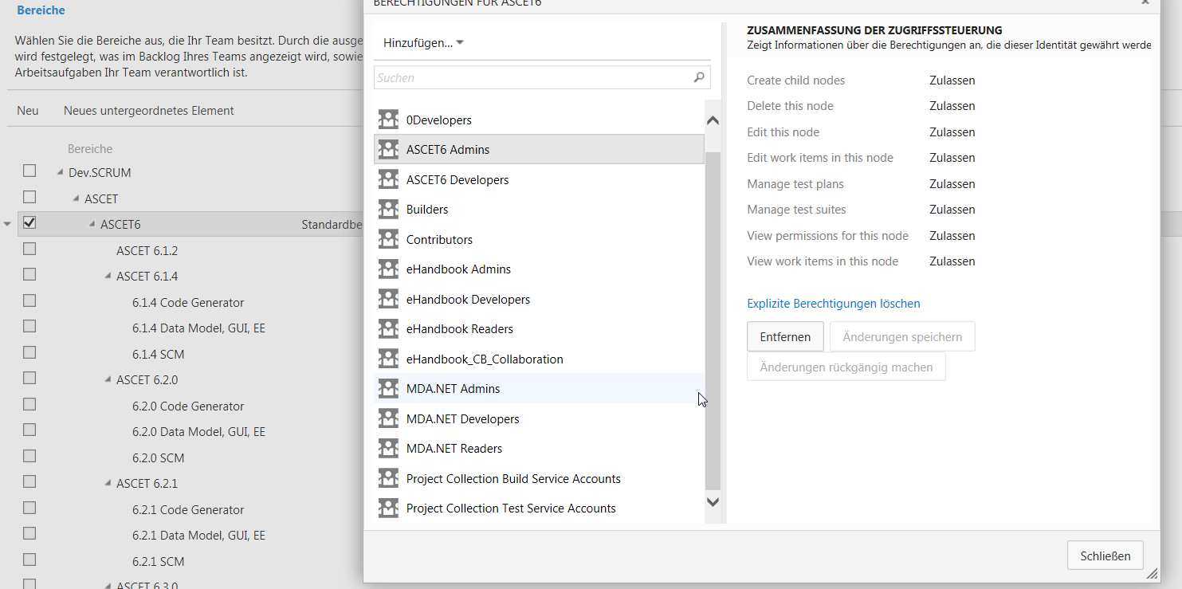
- As DB is getting copied from current prod to previous prod, Permissions remains the same and no change is required in permissions is required for the currently existing teams.
- These steps needs to be done for all the other teams under Dev.Scrum.

